Pharmacy Ordering System

(InfoPharma)

Software

IPOS-PU (Online Platform)

Summary
This is a Requirements Specification and High-Level Design Document, a proposal to the representatives of Info Pharma Ltd: Mr. Lancaster (founder and CEO), Mr Walter (CTO) and Mr Khan (Head of IT), by MediFlow Solutions. Henceforth, the representatives will be referred to as the Client.
Authors
Furqan Khokhar, Bahja Suliman, Dawud Shad, James Cahill, Haris Yasin, Huzefa […], Faisal […]
Note: Please add your surnames to the authors list if they are not currently present.

Contents
1 Preface 3
1.1 Purpose and scope of the document 3
1.2 Intended audience and reading suggestions 3
2 Introduction 3
3 Glossary 4
4 System Requirements 4
4.1 Purpose and scope of the system 4
4.2 System models 4
4.2.1 UML use-case models 4
4.2.1.1 Use case diagram 4
4.2.1.2 Use case specifications (simplified) 4
4.2.1.3 Prioritised list of use cases 4
4.2.1.4 Class diagram (simplified) 5
5 Anticipated evolution of system requirements 5
5.1 Integration with other IPOS subsystems 5
5.2 User interface and customer experience 5
5.3 Promotional features and merchant interaction 5
6 IPOS high-level design 6
6.1 Subsystems 6
6.1.1 IPOS-SA 6
6.1.2 IPOS-CA 6
6.1.3 IPOS-PU 6
6.2 Software architecture 6
6.3 Design diagram of subsystem IPOS-PU 6
6.4 Source code (Java) for the interfaces of IPOS-PU 6
6.5 Testing the communications between the subsystems 6
7 Appendices 7
7.1 Initial statement of requirements by the client 7
7.2 Hardware (minimal and optimal configuration) 7
7.2.1 Minimal hardware configuration 7
7.2.2 Optimal hardware configuration 7
8 Index 7

Preface

Purpose and scope of the document
This is a Requirements Specification for one of the subsystems of the InfoPharma Ordering System (IPOS), IPOS-PU, and the and High-Level Design document for the InfoPharma Software, which includes IPOS-PU and two other subsystems, IPOS-SA and IPOS-CA. The document covers the functional requirement of IPOS-PU and the high-level design of the entire InfoPharma system showing the InfoPharma architecture composed of three subsystems and the mechanisms of interaction between them. The document is provided in response to the initial statement of requirements by Info Pharma Ltd, the Client.
The document explains what the subsystem shall do, and how its subsystems might interact with one another, but does not cover details about how the functionality of the IPOS-PU subsystem will be implemented. Various UML models are used together with fragments of software code to convey in more detail to system developers the expected behaviour of the IPOS-PU subsystem and especially how this subsystem will interact with the other subsystems of IPOS.

Intended audience and reading suggestions
The founder and CEO of InfoPharma Ltd., Mr Lancaster, and system analysis and architects responsible for the development of the IPOS system.
Some of the sections are intended for exclusively technical team members, which is clearly stated in the document prior to the section.

Introduction
IPOS will allow the Info Pharma Ltd to automate their business processes in three interrelated areas: the managing of product catalogue and stock, merchant sales and ordering supplies, and customer sales.
The three areas of planned automation are expected to be covered by three subsystems:
- IPOS-SA A server application to maintain an electronic catalogue of pharmaceutical goods and control stock availability.
- IPOS-CA A client application run on a merchant’s desktop to allow merchants to purchase goods and manage non-commercial customer sales.
- IPOS-PU An online platform to allow non-commercial customers to purchase goods from merchants and run promotions.
IPOS-PU will also be responsible for interfacing with integrating third-party services – SMTP, and Payment Processing, and it will provide these services to IPOS-SA and IPOS-CA as well.
Furthermore, IPOS-PU will generate updates for users on the status of their orders, as well as ensure that IPOS-CA is updated on changes to stock.
As well as this, IPOS-PU will generate reports at the request of an admin – these reports can be on promotional data or sales data.

Glossary
Key Term | Definition
Actor | A human or an external system interacting with IPOS, e.g., Admin, Payment Processor, etc.
IPOS | InfoPharma Ordering System Software
UML | Unified Modelling Language
Use case | A basic interaction of a system with an actor
Interface | A list of functions provided to an external system
Visual Paradigm | A software used to sketch UML diagrams.

System Requirements

Purpose and scope of the system
This section provides a more detailed specification of required functionality (known as system requirements) for IPOS-PU.
The intended audience are the system architects, designers and software developers responsible for the implementation of IPOS. Since we use UML, which requires a degree of specific expert knowledge, we do not expect this section to be immediately useful to the Info Pharma Ltd staff but would like to encourage them to review and comment, if possible.

System models

UML use-case models

Use case diagram
The use case diagram for the IPOS-PU subsystem is shown below in Figure 1. In this diagram, the other subsystems of IPOS are treated as “external systems”, with which IPOS-PU may interact with – particularly when the subsystems require emails to be sent, or payments to be processed.
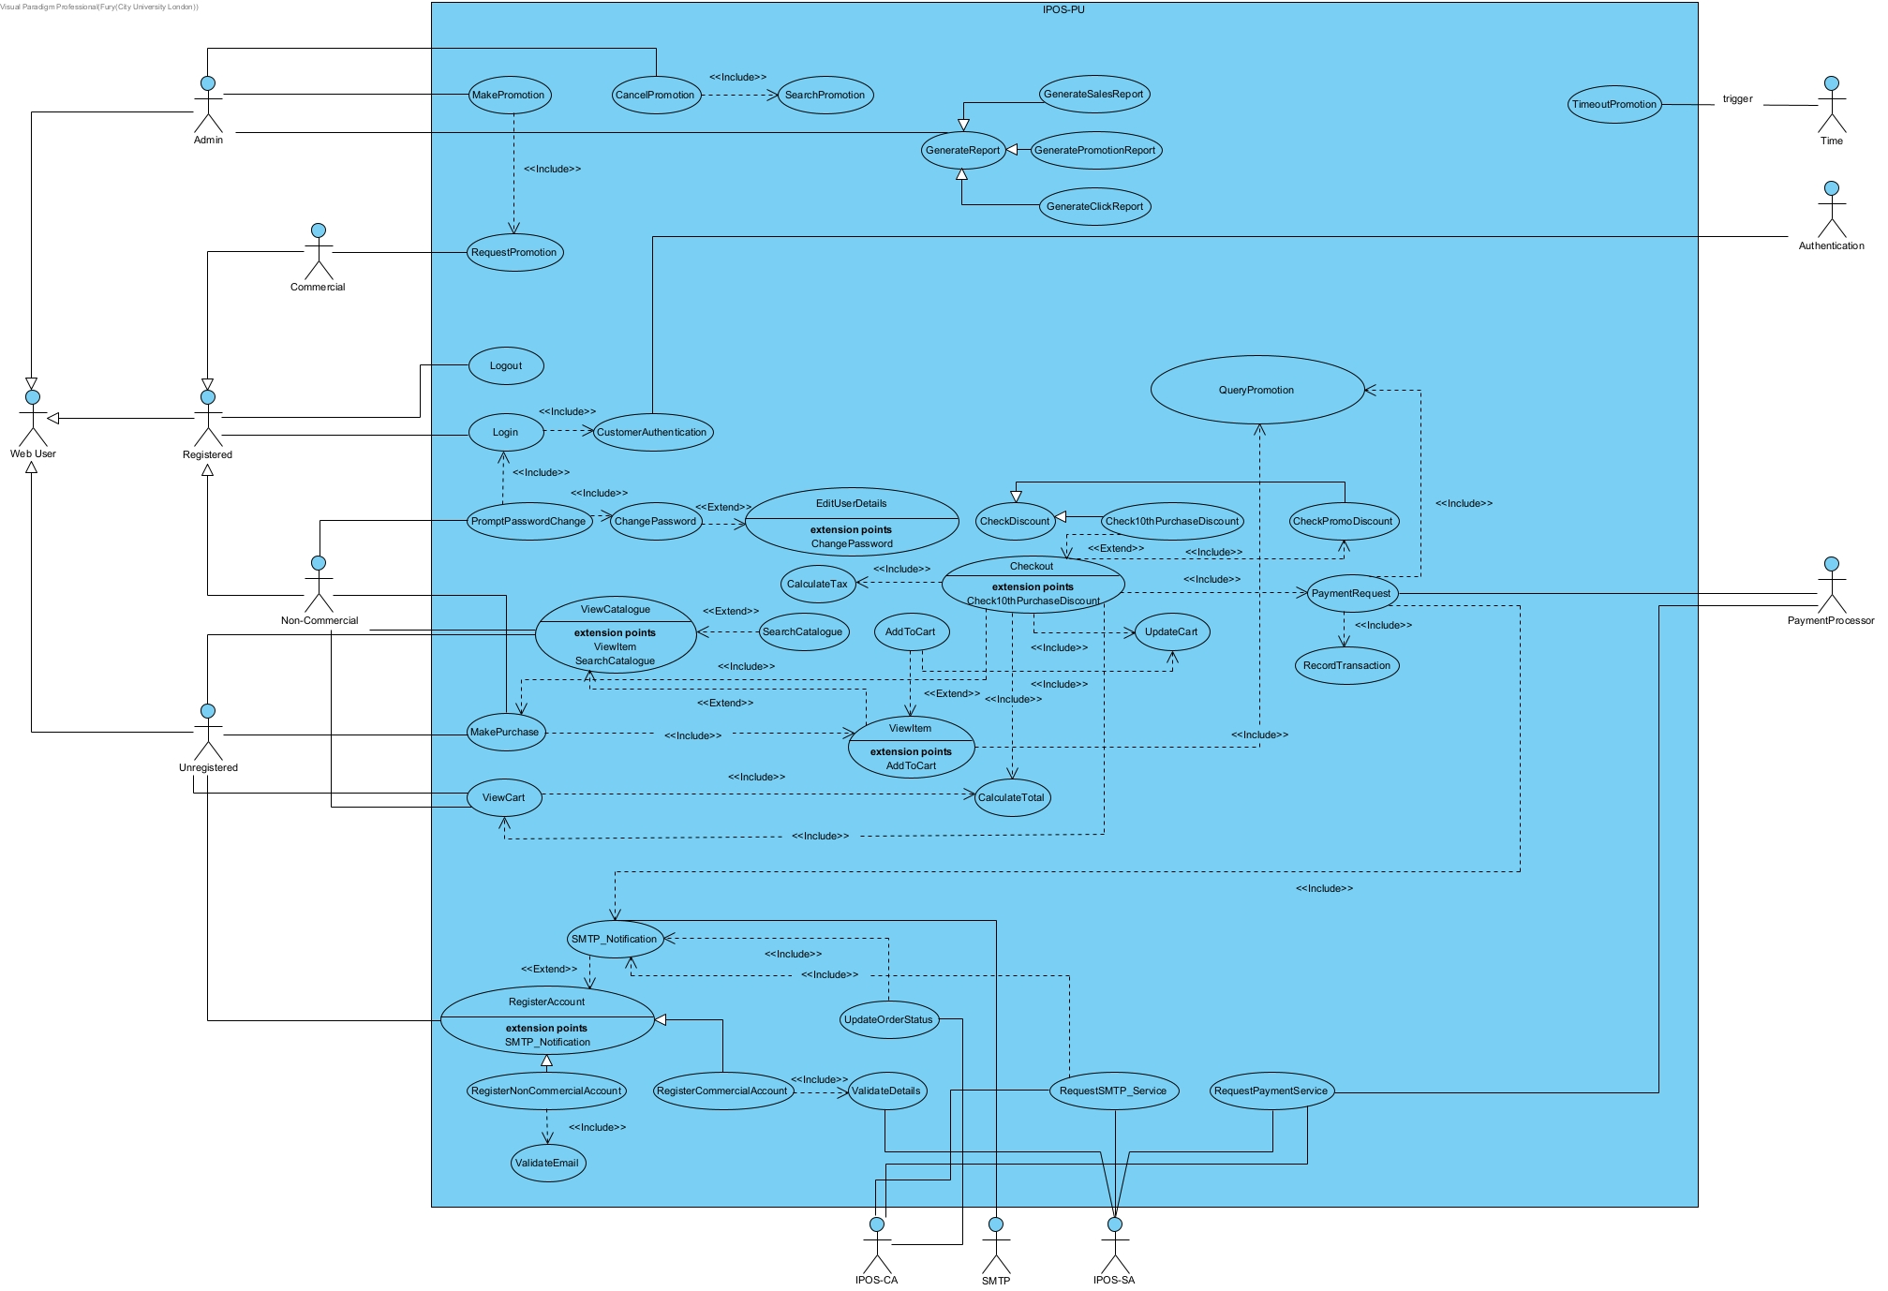Figure 1: Use case diagram of IPOS-PU. The use cases cover the required functionality (see the initial statement of requirements). The actors represent external entities (users or 3rd party systems) which interact with IPOS-PU. The other subsystems of IPOS are also modelled as actors.

Use case specifications (simplified)
A complete set of simplified use case specifications are provided – detailed flows of interaction between actors and subsystems are not included.
[INSERT USE CASE SPECS HERE]

Prioritised list of use cases
The list below prioritises the use cases included in the use case model according to their importance for the IPOS-PU subsystem. InfoPharma’s development team lead will use the assigned priorities to decide on the order of implementing the functionality specified in the use cases according to the resources available: the essential use cases will be implemented first, then the use cases ranked as important will follow. The use cases ranked as good-to-have will be implemented last provided, the resources (manpower and time) are available to complete their implementation.
[INSERT PRIORITISED LIST HERE]

Class diagram (simplified)
This model is solely to be referenced and used by internal team members for the initial phases of development of the IPOS software.
Though the detailed design and implementation of IPOS-PU will take place later, this simplified class diagram begins to depict the classes, interfaces, and enumerations expected in the detailed model.

Anticipated evolution of system requirements
The InfoPharma IPOS-PU subsystem will be deployed as part of the company’s switch from the current manual system to a digitalised platform, however, it does not completely replace the paper-based system that precedes it. Feedback and information gathered from the users, merchants and the stakeholders will shape future changes, and the expected evolution is summarised below in a non-exhaustive list.

Integration with other IPOS subsystems
Currently, systems operate without real-time integration between inventory, catalogue management, and ordering processes.
​As of now systems operate without any synchronisation between the inventory, the catalogue and the ordering processes – this prevents the implementation of locks which could otherwise be used to improve data integrity. To counter this, we may implement a centralised database, shared across all subsystems, with a specialised interface granting functions for each subsystem to enforce the Principle of Least Privilege (PoLP).

User interface and customer experience
Currently, customers interact through direct commutation methods such as through email or phone, which isn’t convenient for consumers. We plan on changing this by introducing an intuitive user interface for notifications that can be accessed within the application itself.

Promotional features and merchant interaction
There aren't any promotional activities limited and not dynamically managed through the digital system. So we vision that merchants can manage promotional campaigns through the promotional content and be able to apply any discounts.

IPOS high-level design
This section defines the high-level design of the entire IPOS software, which includes its architecture – the subsystems which it is made up of, and the communication interfacts between the subsystems.

Subsystems
The subsystems envisaged are:

IPOS-SA
This subsystem will allow Retail Managers of InfoPharma to manage the electronic catalogue of pharmaceutical products provided to merchants, provide order forms, control availability of stock, and generate detailed reports using the system database.

IPOS-CA
This subsystem will allow Merchants to access IPOS-SA’s order forms through an interface and track the status of such orders, manage account holders, track local stock availability and automate orders, record sales, and generate reports.

IPOS-PU
This subsystem will allow members of the public to purchase pharmaceutical goods from merchants, access promotions, and register with InfoPharma to receive special discounts. The subsystem will also allow Online Merchants to register with IPOS-SA, and reports may be generated by Admins.

Software architecture
The architecture of IPOS as a UML component diagram, developed with Visual Paradigm, is shown on Figure 2.
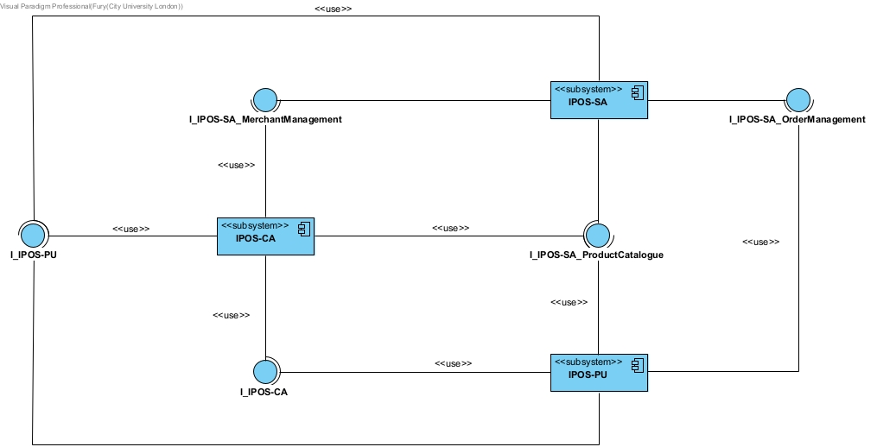Figure 2: IPOS architecture as a UML component diagram. Each subsystem is modelled as a component with stereotype <<subsystem>>. The communication between the subsystems is achieved via a set of assembly connectors (i.e., a pair of "provided" and "required" interfaces referring to the API offered by the respective subsystems. I_IPOS-PU and I_IPOS-CA are provided by IPOS-PU and IPOS-CA respectively, and the APIs are used to access the functionality offered by one of the subsystems by the other two subsystems. IPOS-SA specifically provides three interfaces, separating the APIs used for managing merchants, accessing/updating the product catalogue, and managing orders - these are represented by I_IPOS-SA_MerchantManagement, I_IPOS-SA_ProductCatalogue, and I_IPOS-SA_OrderManagement respectively. Whilst I_IPOS-SA_ProductCatalogue and I_IPOS-SA_OrderManagement are provided to both subsystems, I_IPOS-SA_MerchantManagement is solely provided to the IPOS-CA subsystem.
Figure 2 hides the API details. Using the “presentation options” of Visual Paradigm, one can switch to the “class” notations and disclose full interface details, as is illustrated on Figure 3.

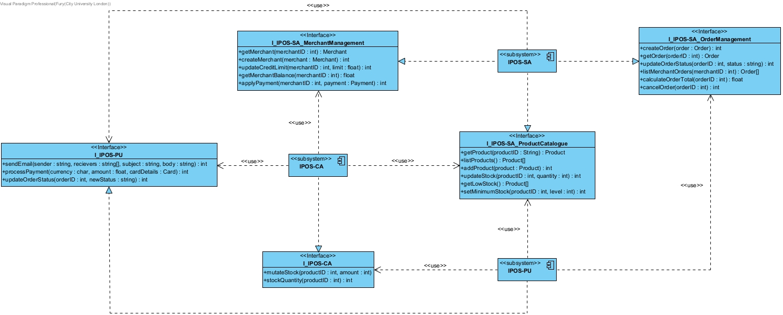Figure 3: Now the methods defined in interfaces are explicitly shown with their full signatures. These are plausible public methods via which the functionality of respective subsystems can be accessed, per collaborative discussions with the teams responsible for the high-level designs of IPOS-SA and IPOS-CA respectively as well. Note that with this change of presentation of the interfaces, the relationships have changed to be more specific as well: the subsystems responsible to implement the interface has a "realisation" relationship with it, implying respective subsystems will contain implementation classes realising the interface. Subsystems that will use an interface are depicted with a usage relationship pointing to the interface that will be used, this can be seen through the "<<use>>" label.
The IPOS architecture includes three subsystems and shows the five necessary interfaces for these subsystems to interact with each other effectively.

Design diagram of subsystem IPOS-PU
Next, we elaborate the high-level design of IPOS-PU and provide details on the interfaces that this subsystem requires, and on the implementation of the subsystem’s own required interface that it provides.
The class diagram of the IPOS-PU subsystem is shown in Figure 4.
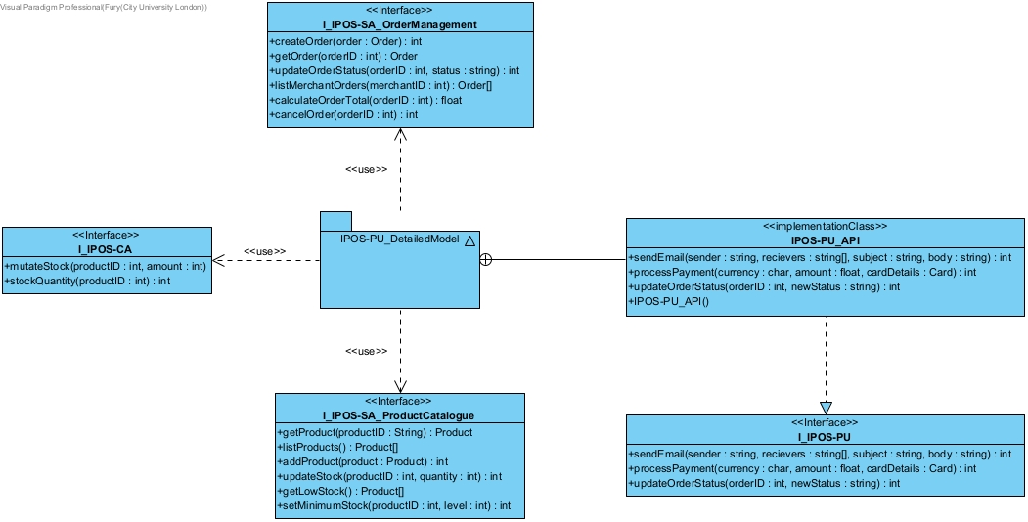

Source code (Java) for the interfaces of IPOS-PU
Now that we have defined all interfaces and the implementation class IPOS-PU_API, source code could be derived (e.g. Java source code) for the interfaces and the implementation classes shown in Figure 4. The complete Java code of the interfaces and a skeleton of the implementation class are shown below generated by Visual Paradigm is provided below, alongside clarifying comments to explain purpose and functionality:

Testing the communications between the subsystems
Now that we have defined the interfaces necessary for communication between the subsystems of IPOS, and generated Java code for all of them, we develop tests for inter-subsystem communication, i.e. of the respective implementation classes that IPOS-PU communicates with.
We have not yet committed to a particular testing platform to run the tests, and so the tests sketched for the methods of these implementation classes will be written generically.

Appendices

Initial statement of requirements by the client

Hardware (minimal and optimal configuration)

Minimal hardware configuration
The minimal hardware configuration recommended for IPOS-PU development consists of:
- Desktop PC or laptop capable of running a Java based desktop application
- 4 GB RAM
- At least 20 GB of free disk space for:
- Application source code
- Compiled program files
- Local database storage (e.g. MySQL or similar DBMS)
- Operating System:
- Windows 10 or later
- Java Runtime Environment (JRE) compatible with the implemented version
- Basic internet connection for:
- Communication with external subsystems (IPOS-SA and IPOS-CA)
- Email/payment service simulation

Optimal hardware configuration
The optimal hardware configuration envisaged for smoother development and testing consists of:
- Desktop PC or high performance laptop
- 8 GB RAM or higher
- At least 100 GB of free disk space for:
- Source code and documentation
- Larger test datasets
- Local database server (e.g. MySQL, PostgreSQL, or similar)
- SSD storage recommended for improved performance
- Operating System:
- Windows 11
- Latest stable Java Development Kit (JDK)
- Stable broadband internet connection for reliable subsystem communication

Index

